**StarLink Satellites & Internet**

Can you imagine the number of satellites increases as the number of stars in space? Over the next few decades, Elon Musk is hoping to send **42,000 satellites** to space which is 15 times of operational satellites in orbit today.

**StarLink Satellites:**

StarLink is a globe-encircling network of internet-beaming satellites from Space X that is trying to get people online no matter where people are in the world, by utilizing a star grouping of **Low Earth Orbit (LEO)** satellites to give fast internet providers.

This framework is fit to give web inclusion to geologically disconnected regions where internet providers don't exist. StarLink utilizes satellite network access innovation that has been around for a long time. Instead of using cable technologies like Fiber optics to deliver internet data, a satellite system sends radio signals across space. Ground stations give signs to satellites in space, moving the data to Earth's StarLink clients.

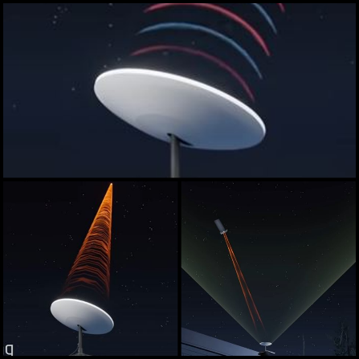**Parts of StarLink Satellites:**

1. Satellite
2. Inside Dishy (Dishy McFlatface)
3. Beem steering
4. Data transfer

**Difference between StarLink and Broadcast devices:**

|  |  |
| --- | --- |
| **StarLink satellites** | **Broadcast devices** |
| * Dishy McFlatface are table-size StarLink satellites. | * . TV dishes use a parabolic reflector to focus the electromagnetic waves which are the TV signals sent from broadcast satellites orbiting the Earth at an altitude of 35 thousand kilometres. |
| * Dishy McFlatface sends and receives internet data from a StarLink satellite orbiting 550 kilo meters away | * TV satellite dishes only receive TV signals from space, they can’t send data. |
| * StarLink satellite is 60 times closer than TV satellites, it’s still an incredible distance to wirelessly send a signal, and thus the beams between Dishy and the StarLink send signals. | * TV broadcast signals which come from a satellite is the size of a van, and whose signals propagate in a wide fan that covers land masses larger than North America. |
| * At least 10,000 StarLink satellites, all circling at unbelievably quick velocities in a low earth circle, are expected to give satellite web to the whole earth. | * It needs to be in a low earth orbit to provide for 20-millisecond latencies, which is critical for smoothly playing internet games or surfing the web, and as a result, their coverage is much smaller. |

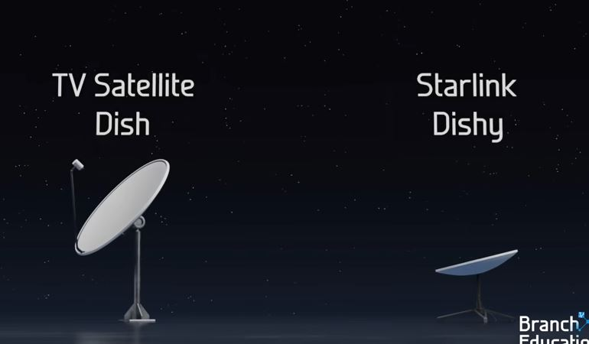

**The goal of StarLink:**

The goal of StarLink is to create low latency and uninterruptable internet all across the world.

**Working of StarLink:**

* 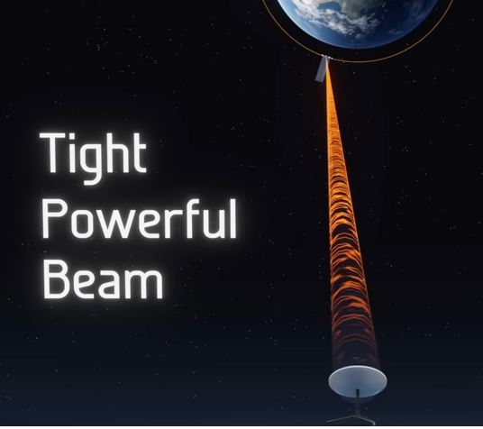StarLink utilizes many small satellites instead of a couple of tremendous ones.
* StarLink utilizes LEO satellites that circle the Earth at just 300 miles above ocean level. This diminished geostationary circle speeds up and diminishes inertness.
* The latest StarLink satellites contain laser correspondence parts that permit signals to be sent between satellites, limiting dependence on a few ground stations.
* The StarLink satellites are the smallest-class CubeSats of about **100 to 500 kg mass** and are launched in Low Earth Orbit at an altitude of about 600 kilometers only.

**Launch of StarLink by SpaceX:**

* SpaceX sent off their most memorable group of 60 StarLink satellites back in May 2019, each has weight around 230 kg.
* The initial plan of SpaceX was to launch a satellite constellation made up of 4000 cross-linked satellites. That number today has expanded considerably more.
* As per the US FCC, the satellites utilize optical between-satellite correspondences, computerized handling innovation in the KU and KA groups, and staged exhibit beamforming.
* The Early StarLink satellites didn't have laser associations. In late 2020, the between satellite laser associations were effectively tested.

**Specifications of StarLink:**

* 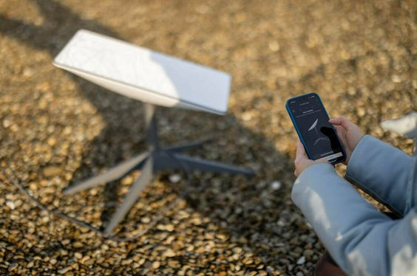SpaceX's non-geostationary orbit communications satellite constellation will operate in high-frequency bands above 24 GHz,
* The minimal theoretical round-trip delay for Internet transmission through a geostationary satellite is 477 milliseconds, although contemporary satellites have 600 m/s or higher latencies.
* StarLink satellites orbit at 1105 to 130 times the height of geostationary orbits, providing more feasible Earth-to-sat latencies of 25 to 35 m/s, comparable to existing cable and fiber networks.
* The framework will utilize a shared convention that is supposed to be "less complex than IPv6," as well as end-to-end encryption.

**Why do StarLink Satellites use Krypton?**

For circle raising and station holding, StarLink satellites utilize Hall-effect engines utilizing krypton gas as the response mass. Compared to a comparable electric propulsion system operated with xenon, krypton Hall thrusters demonstrate much higher flow channel erosion, although krypton is far more common and has a lower market price.

**Advantages of StarLink:**

* Widespread coverage of the internet especially in remote areas.
* High-speed internet
* Low-latency connections

**Disadvantages of StarLink:**

* StarLink's high initial setup cost for the user.
* Requires a clear view of the sky which can be a challenge in urban or forested areas.
* More space debris
* The impact of low Earth orbit satellites on astronomical observations.
* The runaway Kessler syndrome’s possibility.
* A large number of objects floating around at the same elevation from the earth's surface.